ABSTRACT
Object detection and Image processing are combinedly a vast area of research. Various Notable works have been done in the field of transportation in order to ensure a healthy and lawful traffic environment. A precise and quick vehicle number plate recognition system is a solution to traffic control and resultant in improved regulations. This paper is based on optical character recognition which uses improved techniques and ensures optimised results. A full fledged algorithm of number plate recognition is proposed and the same acquires upgraded accuracy over existing system.The entire system can be mounted as a solution traffics issues related to law and security.Automatic Number Plate Recognition (ANPR) system consists integration of machine learning together with image processing and pattern identification. Optical character recognition (OCR) is an algorithm that plays an important role in automatic number plate recognition and it is one of the main aspect of Research in machine learning and computer vision that has evolved immensely since its inception.

INTRODUCTION
Every country uses their own way of designing and allocating number plates to their country vehicles. This license number plate is then used by various government offices for their respective regular administrative task like- traffic police tracking the people who are violating the traffic rules, to identify the theft cars, in toll collection and parking allocation management etc. In India all motorized vehicle are assigned unique numbers. These numbers are assigned to the vehicles by district-level Regional Transport Office (RTO). In India the license plates must be kept in both front and back of the vehicle. These plates in general are easily readable by human due to their high level of intelligence on the contrary; it becomes an extremely difficult task for the computers to do the
same. Many attributes like illumination, blur, background color, foreground color etc. will pose a problem. Also, the License Plate Recognition (LPR) in India is difficult because the traffic rules are hardly obeyed and the number plate standards are not strictly practiced. Each one is adopting a different style
leading to obtaining variation in parameters like, size of number plate and characters, location of number plate, type of font used, background (white background with black letters for non commercial vehicles and white background with yellow letters for commercial vehicles), different unwanted pictures etc. which makes the task of number plate localization very difficult. The main aim of this proposed system is to implement an efficient method to
recognize license plates and extract text from them under Indian conditions. This work is carried over for on car number plates as well as on two wheeler number plates. A typical example of an Indian license plate for car is shown in the figure 1 with the significance of each character (1. State Code, 2. District Code, 3.Type of Vehicle (car, two wheeler, commercial etc.) 4. Actual Registration Number )
Figure 1.1 Format of Licence Plate for Car

INPUT/CAPTURE IMAGE
Capture
The image of the vehicle is captured using a high resolution photographic camera
( preferably). A better choice is an Infrared (IR) camera. The camera may be rolled and
pitched with respect to the license plates . Character recognition is generally very sensitive to
the skew. The readable characters can become distorted due to the obliqueness of the camera.
Using a better camera with more definition and resolution will increase the success ratio of
the system.
Upload
If there is an image that is taken from Camera and saved to the gallery, then that could be
passed as an input to the system by a "Upload" button that we have added in the system in
order to increase and enhance GUI.
READING AND PRE-PROCESSING
The second stage is image pre-processing, which constitutes a crucial stage since it aims
at adequately preparing the image so that the remaining stages can be successfully carried
out. In Image Processing, usually greyscale images are used due to their greater simplicity
compared to colour images. Apart from this, in general, images usually present some
undesired noise that needs to be removed. Besides, for this particular application, where
number plates are the target, it is interesting to highlight within the image certain features
that characterise number plates so that they can later be more easily detected. . This means
that image processing techniques need to be used in order to highlight the vertical lines
appearing in the image and thus, facilitate the subsequent location of the number plate in the
image.
EDGE DETECTION USING CANNY ALGORITHM
Edge detection includes a variety of mathematical methods that aim at identifying points in a
digital image at which the image brightness changes sharply or, more formally, has
discontinuities. The points at which image brightness changes sharply are typically organized
into a set of curved line segments termed edges. Edge detection is a fundamental tool in
image processing, machine vision and computer vision, particularly in the areas of feature
detection and feature extraction.
Canny edge detection is a multistage algorithm to detect a wide range of edges in images to
extract useful structural information from different vision objects and dramatically reduce the
amount of data to be processed. The general criteria for edge detection include:
1. Detection of edge with low error rate, which means that the detection should accurately
catch as many edges shown in the image as possible
2. The edge point detected from the operator should accurately localize on the center of the
edge.
3. A given edge in the image should only be marked once, and where possible, image noise
should not create false edges.
To satisfy these requirements Canny used the calculus of variations – a technique which finds
the function which optimizes a given functional. The optimal function in Canny's detector is
described by the sum of four exponential terms, but it can be approximated by the first
derivative of a Gaussian.

Canny edge detection algorithm
The process can be broken down into 5 different steps:
1. Apply Gaussian filter to smooth the image in order to remove the noise
2. Find the intensity gradients of the image
3. Apply non-maximum suppression to get rid of spurious response to edge detection
4. Apply double threshold to determine potential edges
5. Track edge by hysteresis: Finalize the detection of edges by suppressing all the other edges
that are weak and not connected to strong edges.

OCR AND PYTESSERACT
Optical Character Recognition involves the detection of text content on images and
translation of the images to encoded text that the computer can easily understand. An image
containing text is scanned and analyzed in order to identify the characters in it. Upon
identification, the character is converted to machine-encoded text.
The image is first scanned and the text and graphics elements are converted into a bitmap,
which is essentially a matrix of black and white dots. The image is then pre-processed where
the brightness and contrast are adjusted to enhance the accuracy of the process.
The image is now split into zones identifying the areas of interest such as where the images
or text are and this helps kickoff the extraction process. The areas containing text can now be
broken down further into lines and words and characters and now the software is able to
match the characters through comparison and various detection algorithms. The final result is
the text in the image that we're given.
In short OCR is a process which generally consists of several sub-processes to perform as
accurately as possible. The subprocesses are:
• Preprocessing of the Image
• Text Localization
• Character Segmentation
• Character Recognition
• Post Processing
The sub-processes in the list above of course can differ, but these are roughly steps needed to
approach automatic character recognition. In OCR software, it’s main aim to identify and
capture all the unique words using different languages from written text characters.
Python-tesseract is an optical character recognition (OCR) tool for python. That is, it will
recognize and “read” the text embedded in images.Python-tesseract is a wrapper for Google’s
Tesseract-OCR Engine. It is also useful as a stand-alone invocation script to tesseract, as it can
read all image types supported by the Pillow and Leptonica imaging libraries, including jpeg,
png, gif, bmp, tiff, and others. Additionally, if used as a script, Python-tesseract will print the
recognized text instead of writing it to a file.

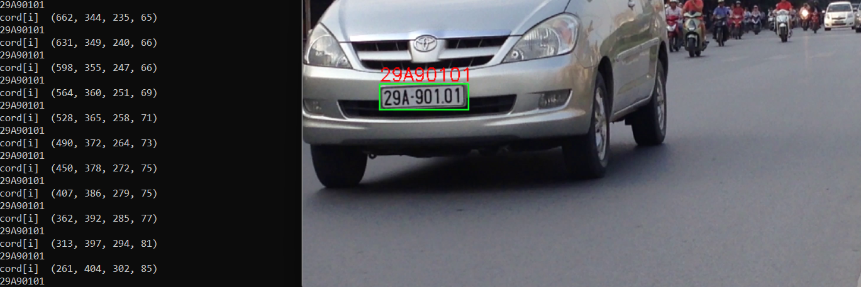

CONCLUSION :
An efficient approach for number plate extraction is presented in this paper. The proposed method is mainly designed for real-time Indian vehicles number plate but it also works well for foreign number plates. This extraction process works well for low resolution, noisy and low contrast images

